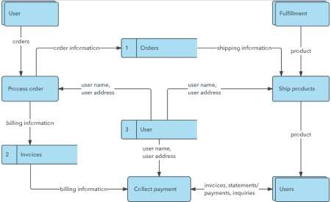

Project Design Phase-II

Data Flow Diagram & User Stories

|  |  |
| --- | --- |
| Date | 03 October 2022 |
| Team ID | PNT2022TMID05007 |
| Project Name | Project- Plasma Donor Application |
| Maximum Marks | 4 Marks |

# Data Flow Diagrams:

A Data Flow Diagram (DFD) is a traditional visual representation of the information flows within a system. A neat and clear DFD can depict the right amount of the system requirement graphically. It shows how data enters and leaves the system, what changes the information, and where data is stored.

Example: DFD Level 0 (Industry Standard)

# Example: [(Simplified)](https://developer.ibm.com/patterns/visualize-unstructured-text/)

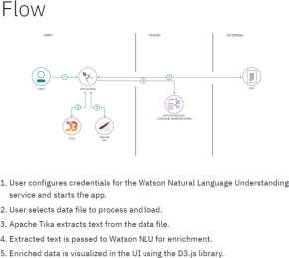

**Dataflow Diagram(Plasma Donor Application):**

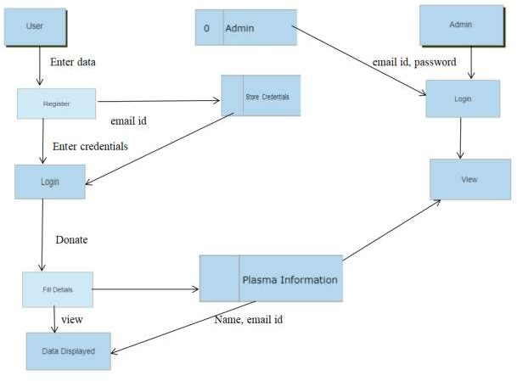

# User Stories

Use the below template to list all the user stories for the product.

|  |  |  |  |  |  |  |
| --- | --- | --- | --- | --- | --- | --- |
| **User Type** | **Functional Requirement (Epic)** | **User Story Number** | **User Story / Task** | **Acceptance criteria** | **Priority** | **Release** |
| Customer (Mobile user) | Registration | USN-1 | As a user, I can register for the application by entering my email, password. | I can access my account dashboard | High | Sprint-1 |
|  |  | USN-2 | As a user, I will receive confirmation email  once I have registered for the application | I can receive successful  message | High | Sprint-1 |
|  | Login | USN-3 | As a user, I can log into the application by entering email & password | I can access into my  Profile and view my dashboard | High | Sprint-1 |
|  | Dashboard | USN-4 | As a user, I can login using my credentials and it will direct it to my dashboard | I can view and access what are the features are provided  in dashboard | High | Sprint-1 |
| Customer (Webuser) |  | USN-5 | As a user, I can login using my  credentials and it will direct it to my dashboard | I can view and access what are the features are provided in dashboard | High | Sprint -1 |
| Customer Care Executive | Query | USN-6 | As a user had an any query about the given requirements | I can view a query and rectify the given query | medium | Sprint-2 |
| Administrator | Login | USN-7 | As a admin ,have credentials using that they can login | They can view and modify the data in database | medium | Sprint-2 |
|  | View | USN-8 | As a admin I can view plasma information | View and modify | High | Sprint-1 |
|  | Modify | USN-9 | As a admin I can modify the plasma information. | Modify only if there is a false  information/ | Medium | Sprint-1 |